**Optimal settings for printing ventilator splitters:**

1. Layer height: 0.2mm (95% of the stock nozzles on 3D printers are of 0.4mm-keep layer height as 0.5 x nozzle diameter for optimal strength and print time.)
2. Perimeters/outer walls: 5 perimeters are suggested for maximum strength.
3. Infill: 50-60% suggested for maximum strength. Anything more than this is redundant.
4. Path overlap: Max 30%. This setting ensures the walls of the part do not strip off.
5. Print speed: 40-60mm/sec is ideal for most printers. The more rigid the frame of a printer is, the higher speed it can print at.
   1. Keep the first layer speed as low as 20-30 mm/sec to make sure the first layer sticks
   2. Increasing extrusion ratio to 110-120% can also help to stick the first layer to the bed.
6. Printing temperature: 190-220 deg Centigrade for most commercial PLA brands.
7. No supports needed for both the variants of splitters.
8. The splitters can be oriented according to the below images while printing, to prevent cracking.

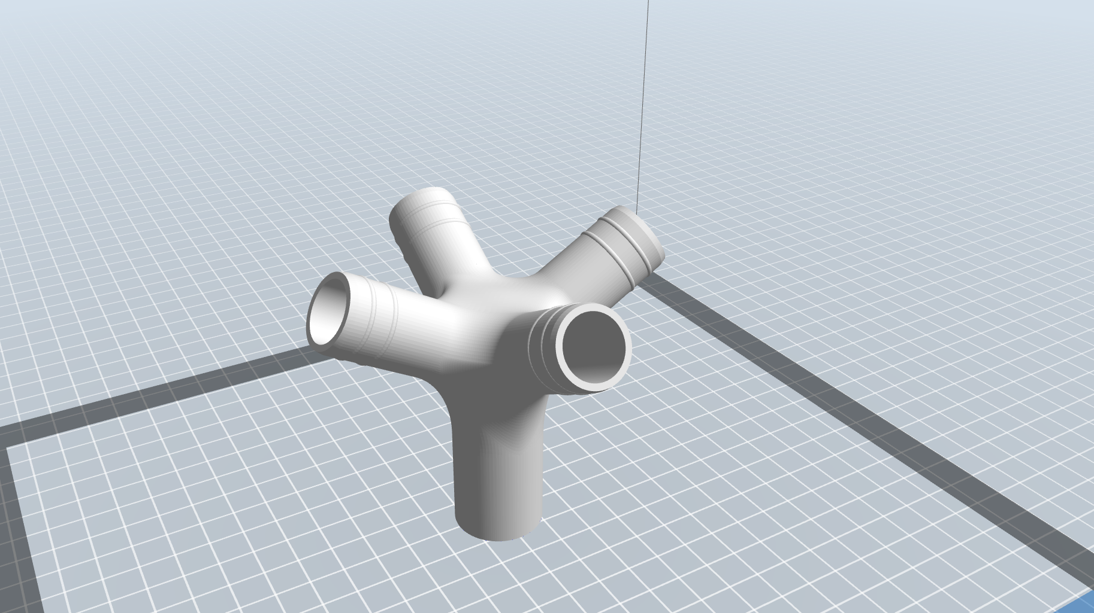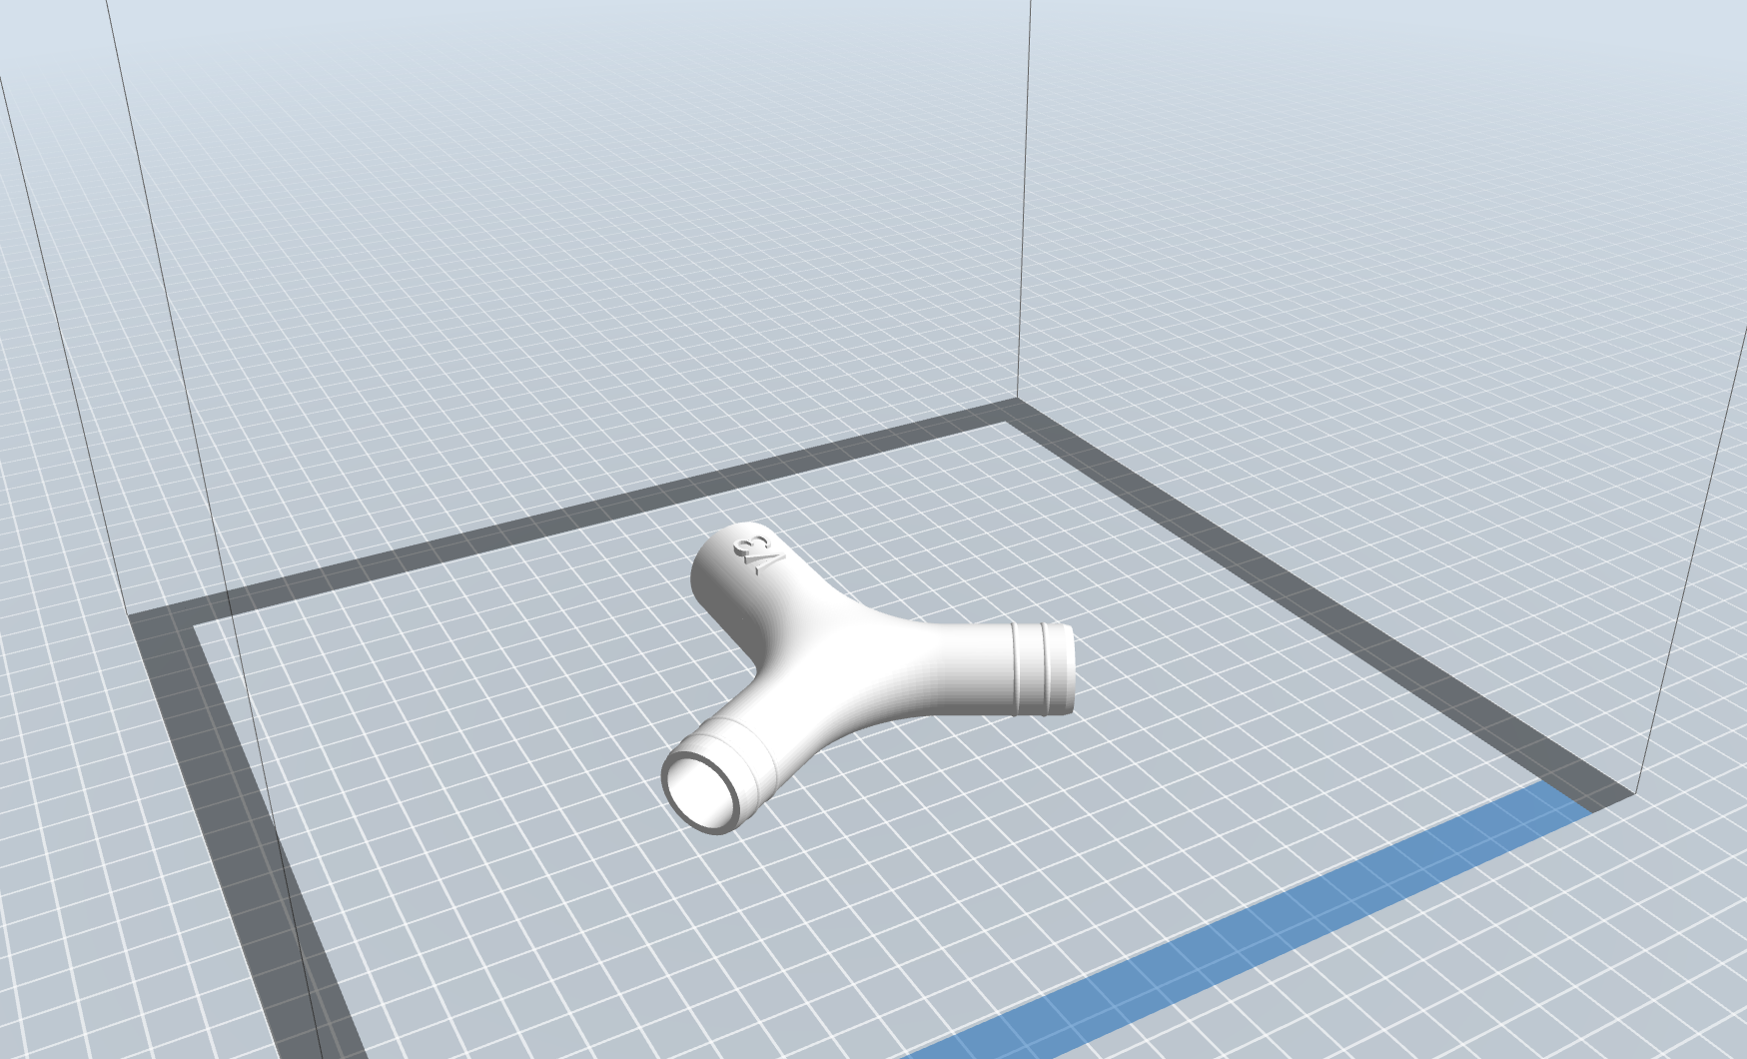

Please contact

1. Mr. Srinivas Kumar,

Ph: 9980911558, Email: Srini@wizardry.co.in

1. Mr. Harsha,

Ph: 8016367306, Email: harsha@soch3d.com, [harshamadalam@gmail.com](mailto:harshamadalam@gmail.com)

for any further clarifications.